NAME: KARTHIGA G SLOT: A
REG NO:192421383 SUB: CLOUD COMPUTING
4. CAR BOOKING RESERVATION SYSTEM (SaaS)
AIM
To develop a Car Booking Reservation System and deploy it as SaaS using Zoho Creator.
ALGORITHM
- Start
- Login to Zoho Creator
- Create new application
- Create car booking form
- Add booking details fields
- Create report
- Run application
- Enter booking data
- Display booking details
- Share application link
- Stop
PROCEDURE
- Create application (CarBookingApp)
- Create form (CarBookingForm)
- Add fields: Name, Phone, Car Type, Pickup, Drop, Date, Time, Email
- Create report (CarBookingReport)
- Run application and enter data
- View booking details in report
- Share application link

OUTPUT SCREENSHOT
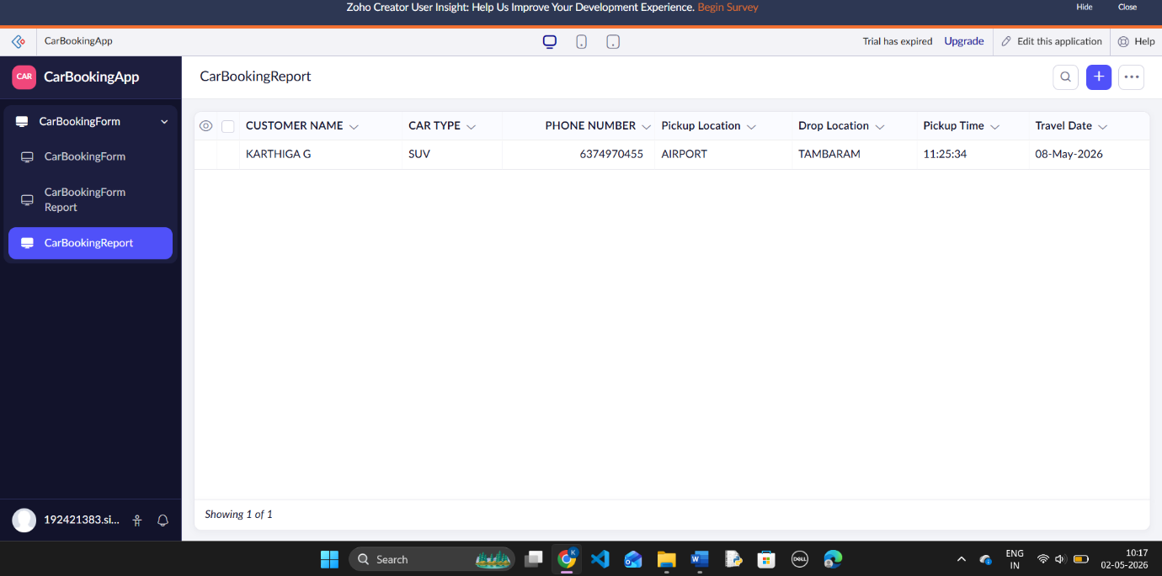

RESULT
A Car Booking Reservation System was successfully developed and deployed as SaaS using Zoho Creator.

